Alexander Baldree
07/08/26
Module 7.2 Project part 2
CSD430

GitHub Link:
https://github.com/Panda-Alex21687/CSD430

VS Code Project Folder:
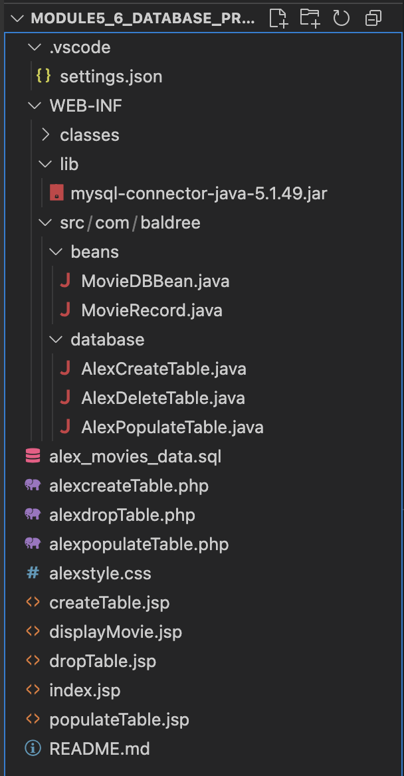

Index.jsp:
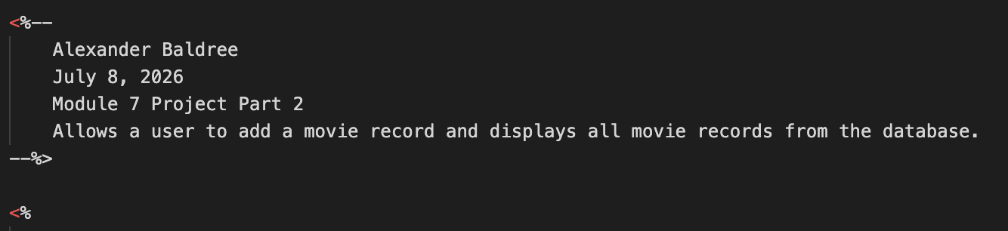
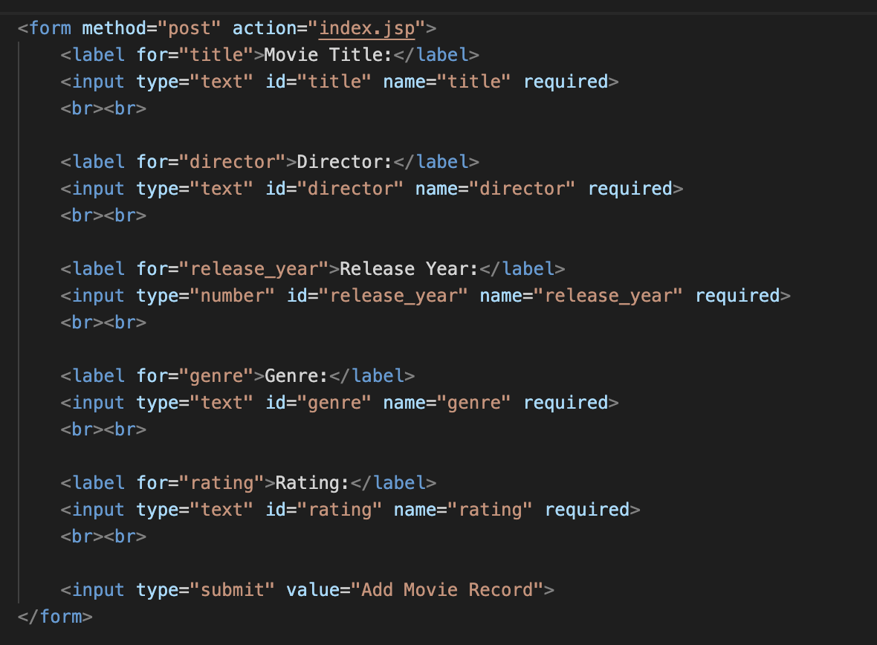

Database Java File:
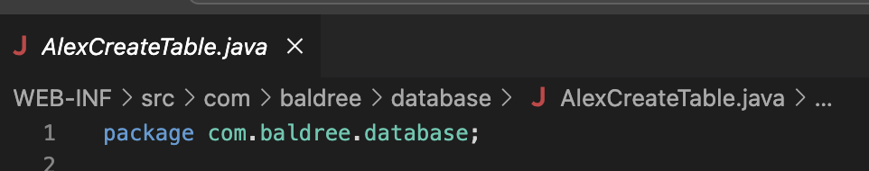
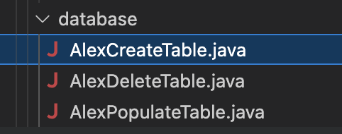

Compile Successful:
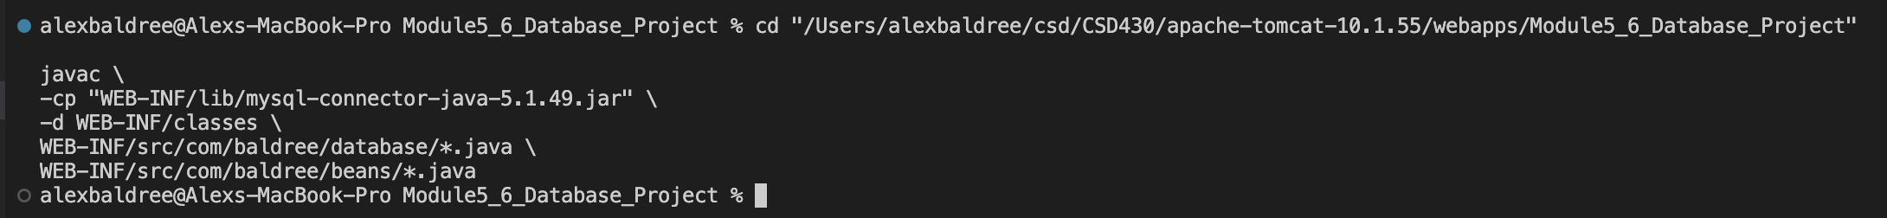
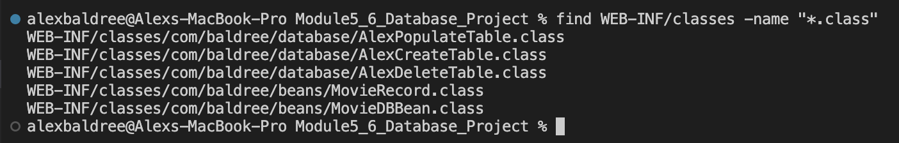

MySQL table:
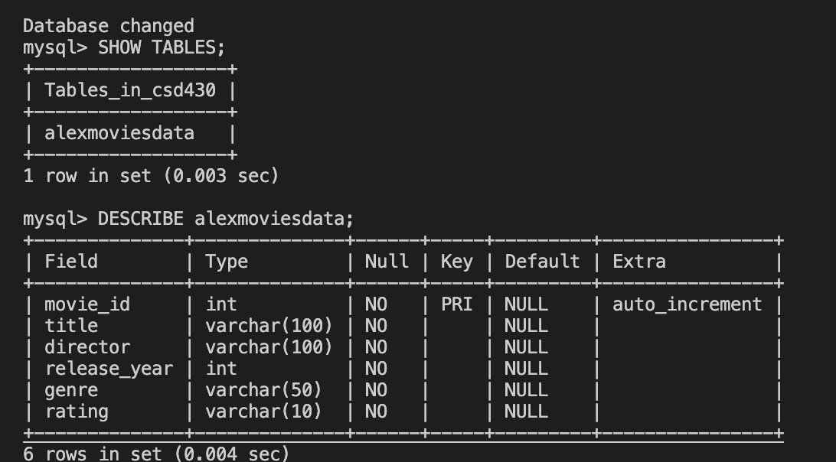

MySQL records before adding new one:
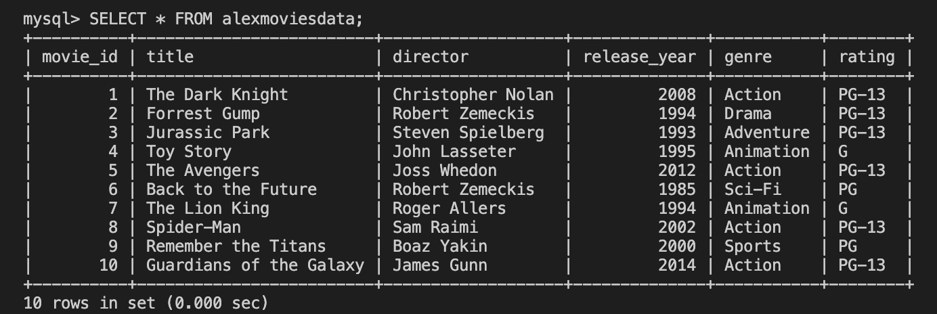

Tomcat Started:
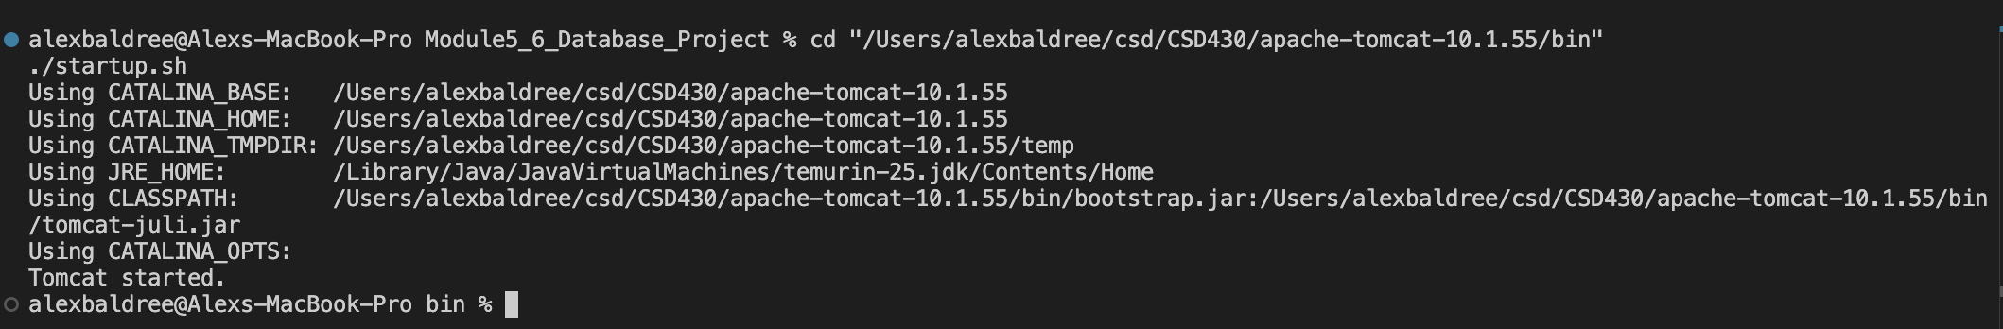

Browser before adding a record:
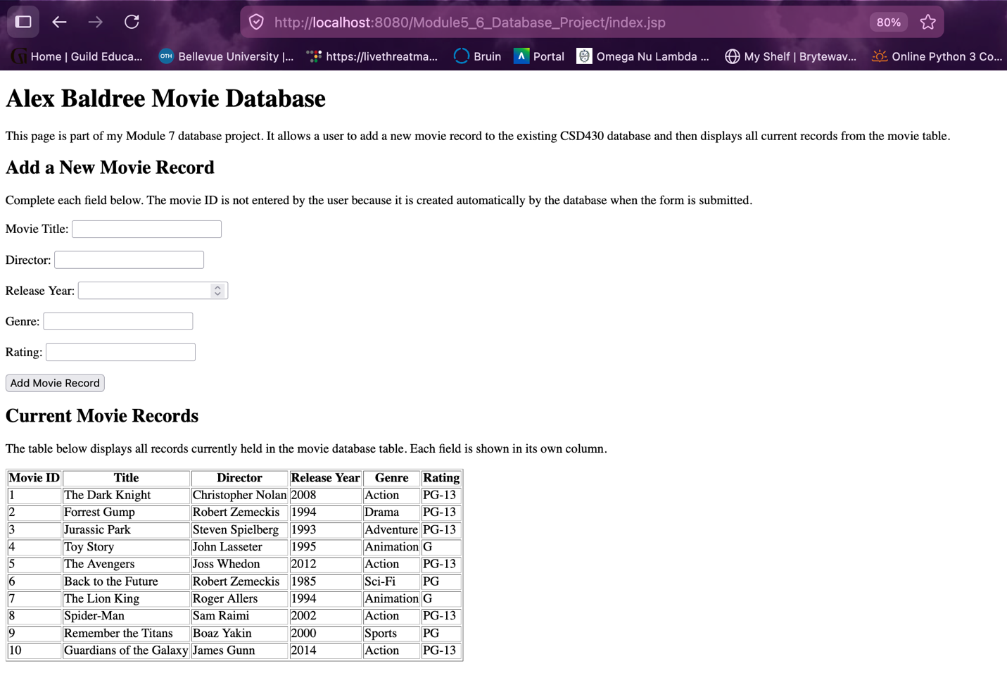

Form Filled Out:
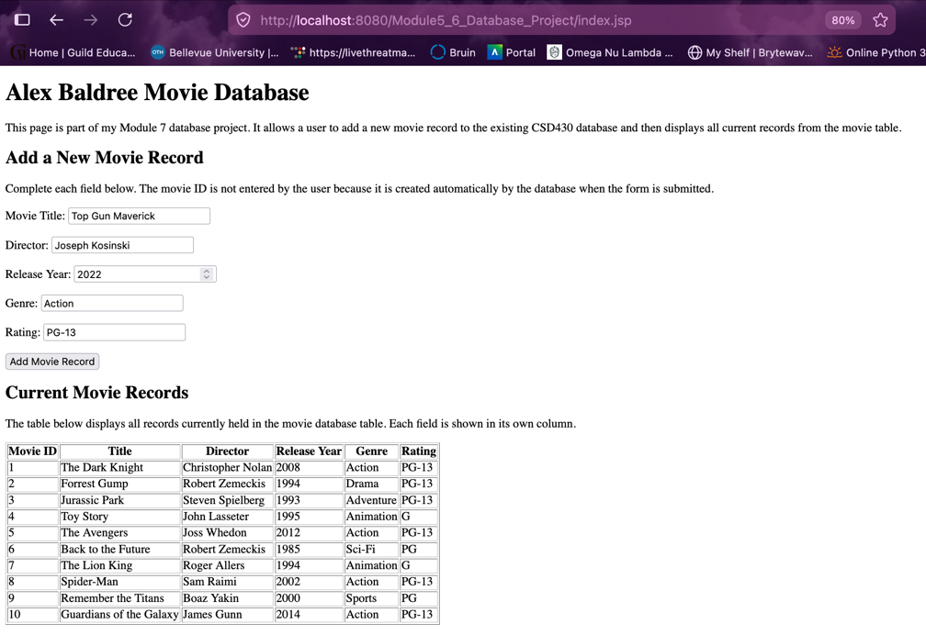

After submitting form:
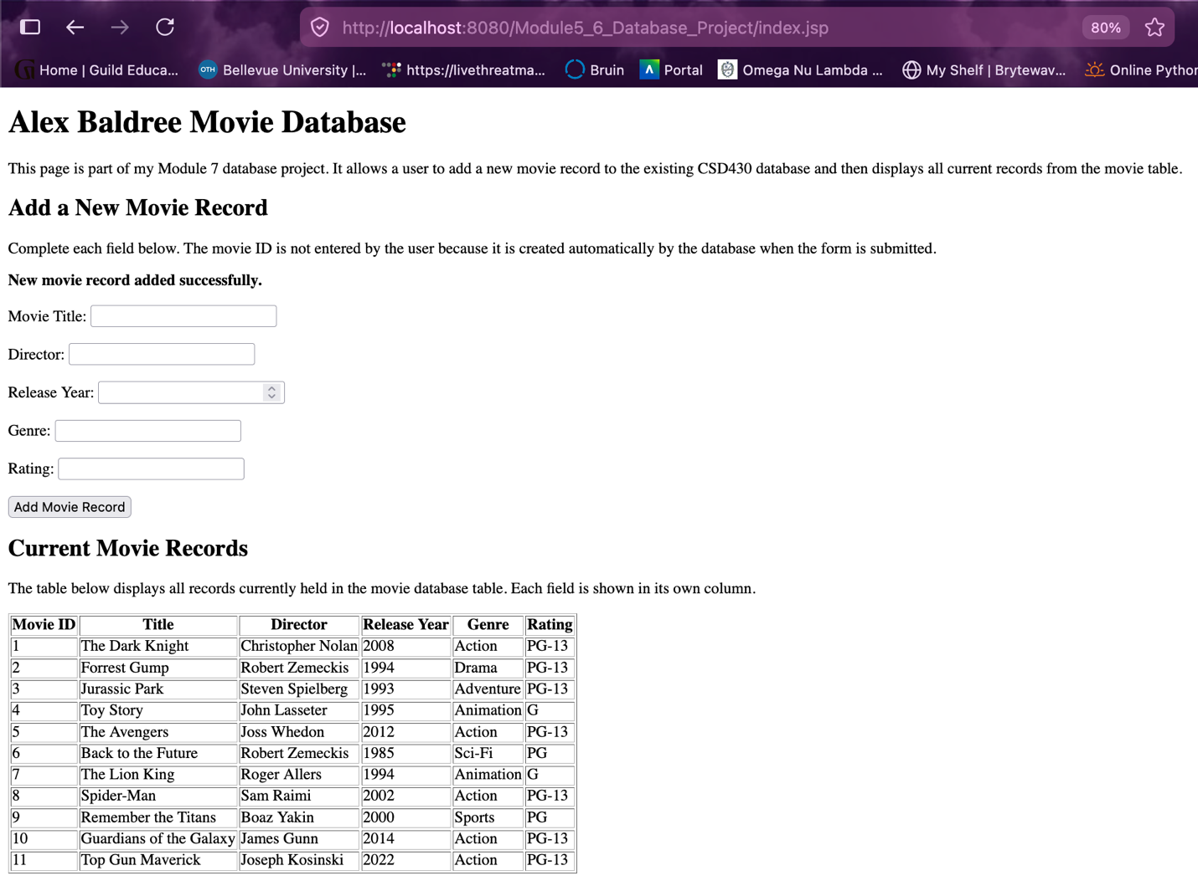

MySQL after adding the new record:
